COMP 3710 Artificial Intelligence
Fall 2013
Term test III

Student Name: Student Number:

- (10 marks) Let’s consider a backpropagation neural network. This network has 10 nodes in the hidden layer and 2 nodes in the output layer. Let outputH be the array for the output values from the hidden layer to the output layer. Let outputO be the array for the output values from the output layer. Let the learning rate be 0.15. Let weightHO be the weight matrix between the hidden layer and the output layer. The expected values from the output layer are 1 and 0.
- Assuming the step function with threshold 0.1 as the activation function for the nodes in the output layer, write the program code to compute outputO.

- Write the program code to compute the delta values, deltaO, for the nodes in the output layer.

- Write the program code to compute the delta values, deltaH, for the nodes in the hidden layer.

- Write the program code to update the weight matrix weightHO.

- (4 marks) Explain how supervised learning and unsupervised learning are different. Identify which ones among Hopfield networks, Kohonen Maps, BAM, and Hebbian networks, use unsupervised learning.

- (6 marks) Consider the next facts.
P(a) = 0.2 P(b) = 0.5 P(a|b) = 0.3 P(a|¬b) = 0.25
- Compute P(a∧b).

- Compute P(a∨b).

- Compute P(b|a)

- Compute P(¬a|b):

- (5 marks) Consider the next joint probability distribution.
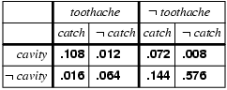

- (2 marks) Let M be meningitis and S be stiff neck, where the stiff neck is one symptom of meningitis. What is the probability of having meningitis with stiff neck when P(s) = 0.2, P(m) = 0.0001, P(s|m) = 0.9?

- (6 marks) Consider the next Bayesian network.
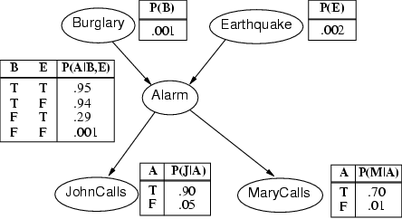
- Compute the probability that the alarm rings and there is not burglary.

- Compute the probability that John calls, Mary does not call, the alarm does not ring, there is no earthquake and there is burglary.

